The 5 Thesis-Story Answers
Revenue model — how Waystar charges: Over 99% of our revenue is either recurring subscription or based on highly predictable volumes. We primarily generate two types of revenue: (i) subscription revenue and (ii) volume-based revenue, which account for 99% of total revenue for all periods presented
Revenue growth rate — For the six months ended June 30, 2023, we generated revenue of $387.1 million (reflecting a 12% increase compared to revenue of $344.8 million for the same period in the prior year), net loss of $21.4 million (reflecting a 16% decrease compared to net loss of $25.4 million for the same period in the prior year). For the year ended December 31, 2022, we generated revenue of $704.9 million (reflecting a 22% increase compared to revenue of $578.6 million in the prior year), net loss of $44.0 million (reflecting a 6% decrease compared to net loss of $47.1 million in the prior year)
Adjusted EBITDA margin — Adjusted EBITDA of $166.5 million (reflecting a 16% increase compared to Adjusted EBITDA of $143.6 million for the same period in the prior year). and what specifically gets added back to get there. For the year ended December 31, 2022 adjusted EBITDA of $295.5 million (reflecting a 16% increase compared to Adjusted EBITDA of $254.5 million in the prior year)
Total debt load — going into the IPO
EQT's value creation story — what they say they did to the business 2019-2024

The ~15 Supporting Numbers
Revenue mechanics
- Total revenue, last 3 years
- Revenue split: subscription vs. transaction – Subscription – 70%. Transaction -30% : 50% transaction count from provider solutions and the other 50% from patient payments solutions that are based on either dollar volumes or transaction count. Third-party costs for patient payments solutions are approximately 60% of the revenue generated from these solutions, while third-party costs for provider solutions are approximately 6% of the associated revenue.
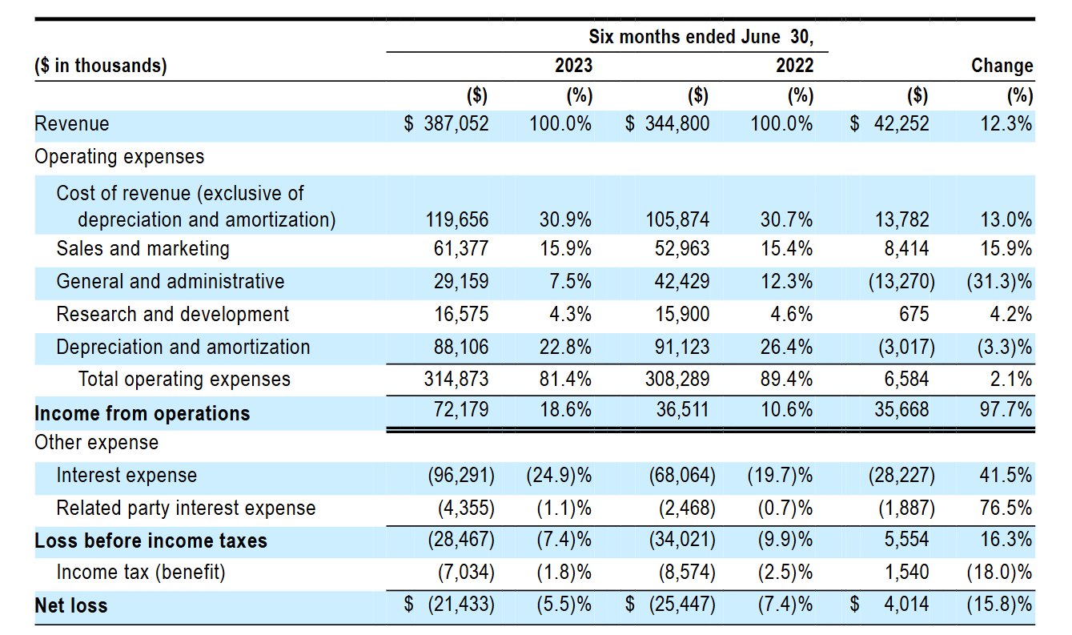

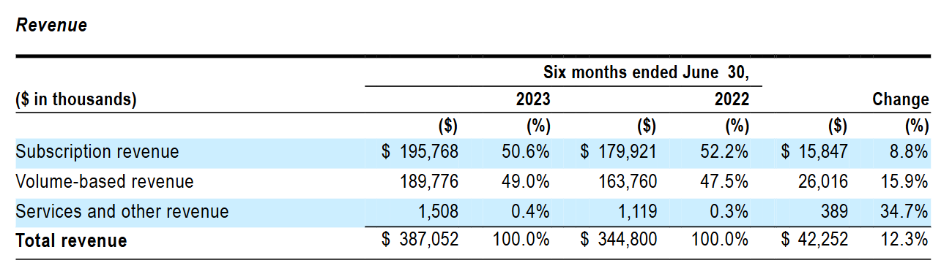

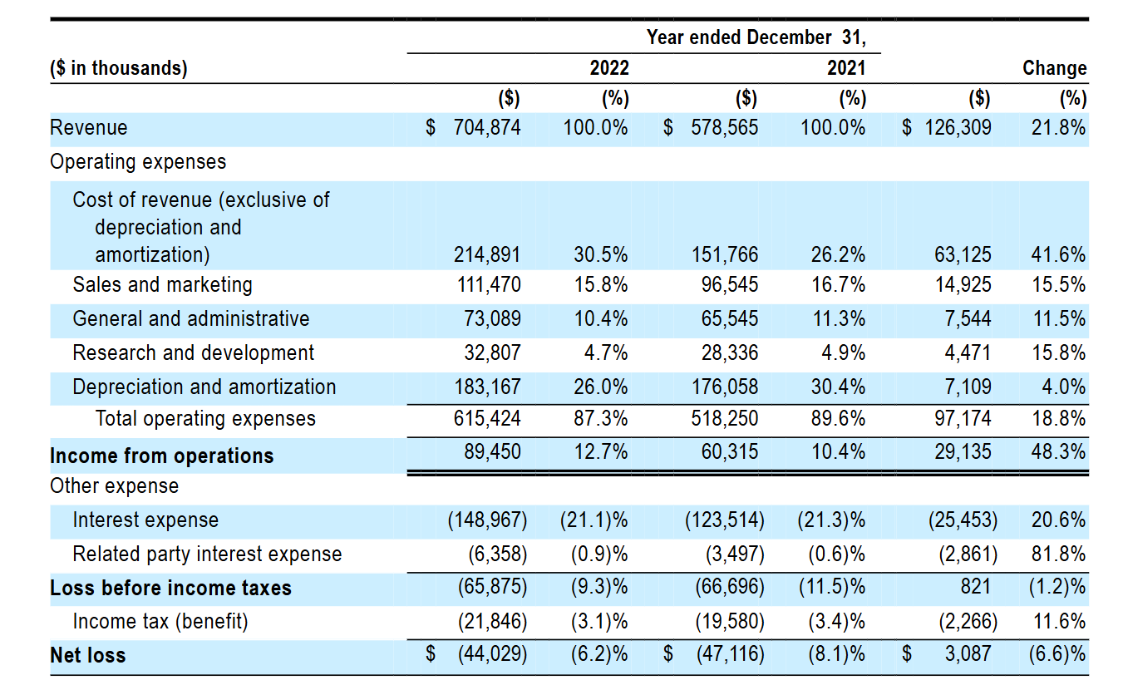

- Number of clients (and how they define "client") - We currently serve approximately 30,000 clients of various sizes, representing approximately one million distinct providers practicing across a variety of care sites, including 18 of the top 22 U.S. News Best Hospitals. Our client base is highly diversified, and for the six months ended June 30, 2023 and the year ended December 31, 2022, our top 10 clients accounted for only 11.7% and 11.4%, respectively, of our total revenue. The number of clients from whom we generate over $100,000 of revenue has grown from 733 in the twelve months ended March 31, 2021 to 1,023 in the twelve months ended June 30, 2023
- NRR (Net Revenue Retention) - For the twelve months ended June 30, 2023, our Net Revenue Retention Rate was 109.7%, and for the year ended December 31, 2022, our Net Revenue Retention Rate was 109.5%.
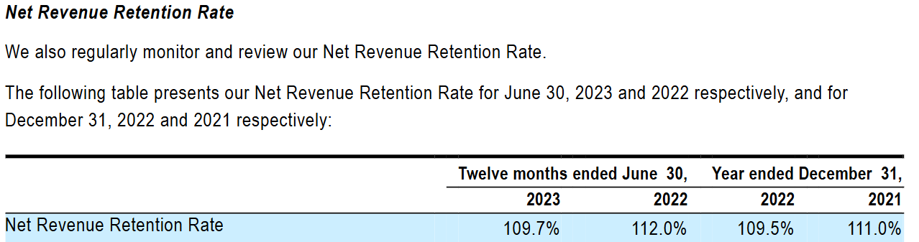
- GRR (Gross Revenue Retention)
Profitability
- Gross margin %
- Adjusted EBITDA ($ and margin %)
- The addback reconciliation table — what's added back and how much
Scale indicators
- Total dollar volume of claims/transactions processed
- Number of providers on platform
- Number of payer connections
Capital structure
- Total debt pre-IPO $1.74 billion of first lien debt
- IPO proceeds raised
- What proceeds were used for (almost always debt paydown)

